Individual Application
Imperial Lettings
Tel: 0121 347 6418 Email: imperial@mail.org )

YOU MUST READ THE FOLLOWING INFORMATION BEFORE COMPLETING THIS APPLICATION MISSING OR INCOMPLETE INFORMATION WILL DELAY YOUR APPLICATION
Please use black ink and CAPITAL LETTERS throughout the form.
What you must do to ensure that we can process your application quickly and efficiently: | Tick After  Completed & Checked
o Detail all requested telephone numbers including full dialling codes | ◻
o Detail all requested addresses fully including full postcodes | ◻
o Please provide one proof of residency (not more than 4 months old) from the following & Also Your  Passport (including any Residency Permits if required): | ◻
If any of the items on the left are unavailable please supply at least 2 from the following:
Bank statement, Official letter (from council or government department) or driving license.
Each must be from a separate source and one must be less than 4 months old.
Passports are not acceptable as proof of residency
- Utility Bill
- Council Tax Bill
- Mobile / Telephone Bill
- Credit Card Statement
o Contact all referees to advise that we will be contacting them and, if requested, supply them written authority ◻
Only by providing complete information can we ensure that your application is dealt with promptly.
 - Where you see this symbol your application cannot be processed if this information is missing.
SECTION 1 – TO BE COMPLETED BY YOUR LETTING AGENT. (To clarify for which property you are applying, you may insert the address.)
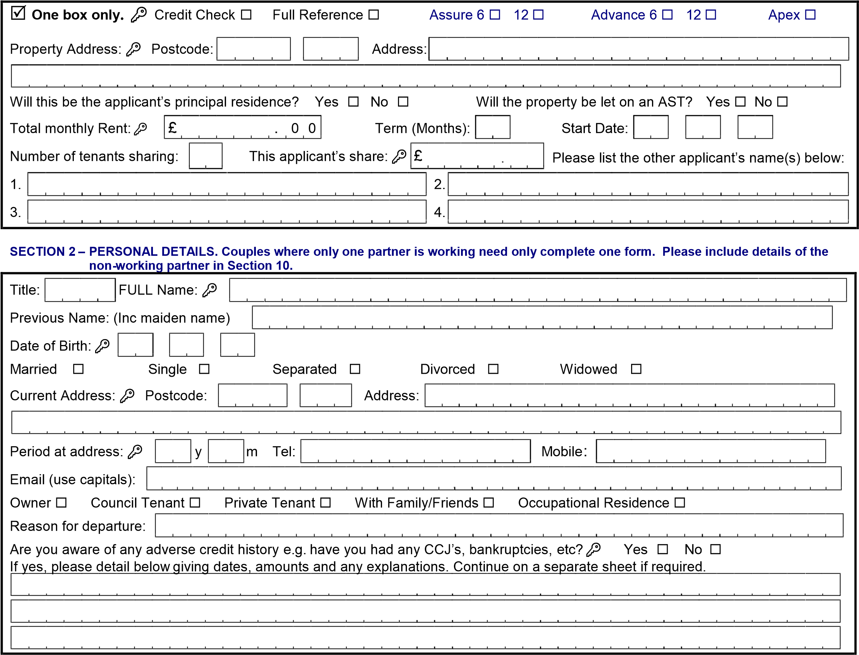
SECTION 3 – PREVIOUS ADDRESSES  – please give all addresses for the last three years, on a separate sheet if required. If you have been resident outside the UK for the last 3 years please supply your last UK address.
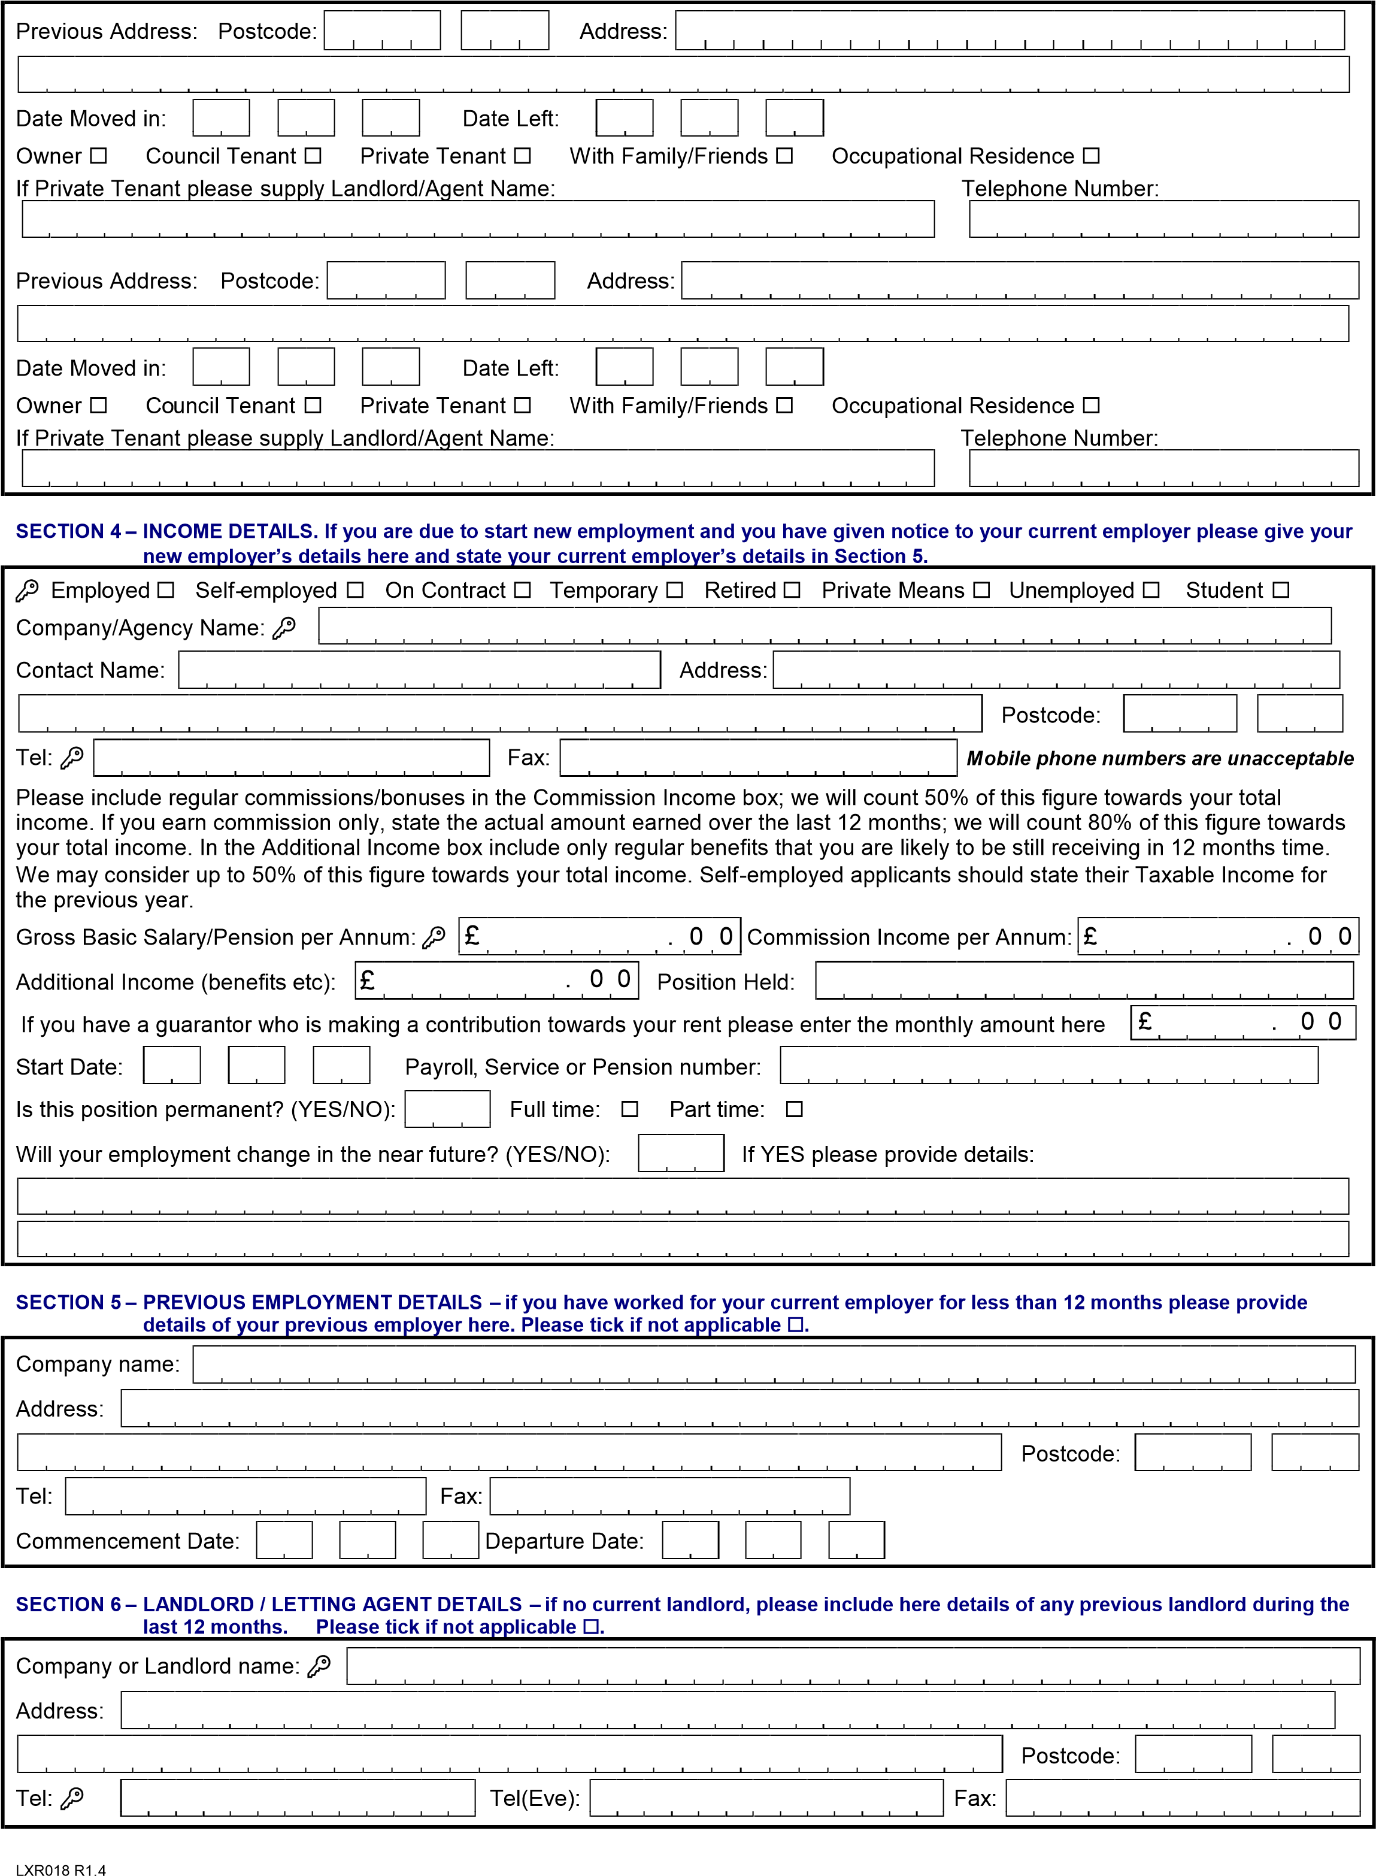

SECTION 7 – ACCOUNTANT DETAILS – only required for self-employed applicants. Please authorise your accountant/auditor to provide us with a reference when we request it. Please tick if you do not have an accountant. ◻ We may need to see copies of your tax returns. Please tick if not applicable ◻.
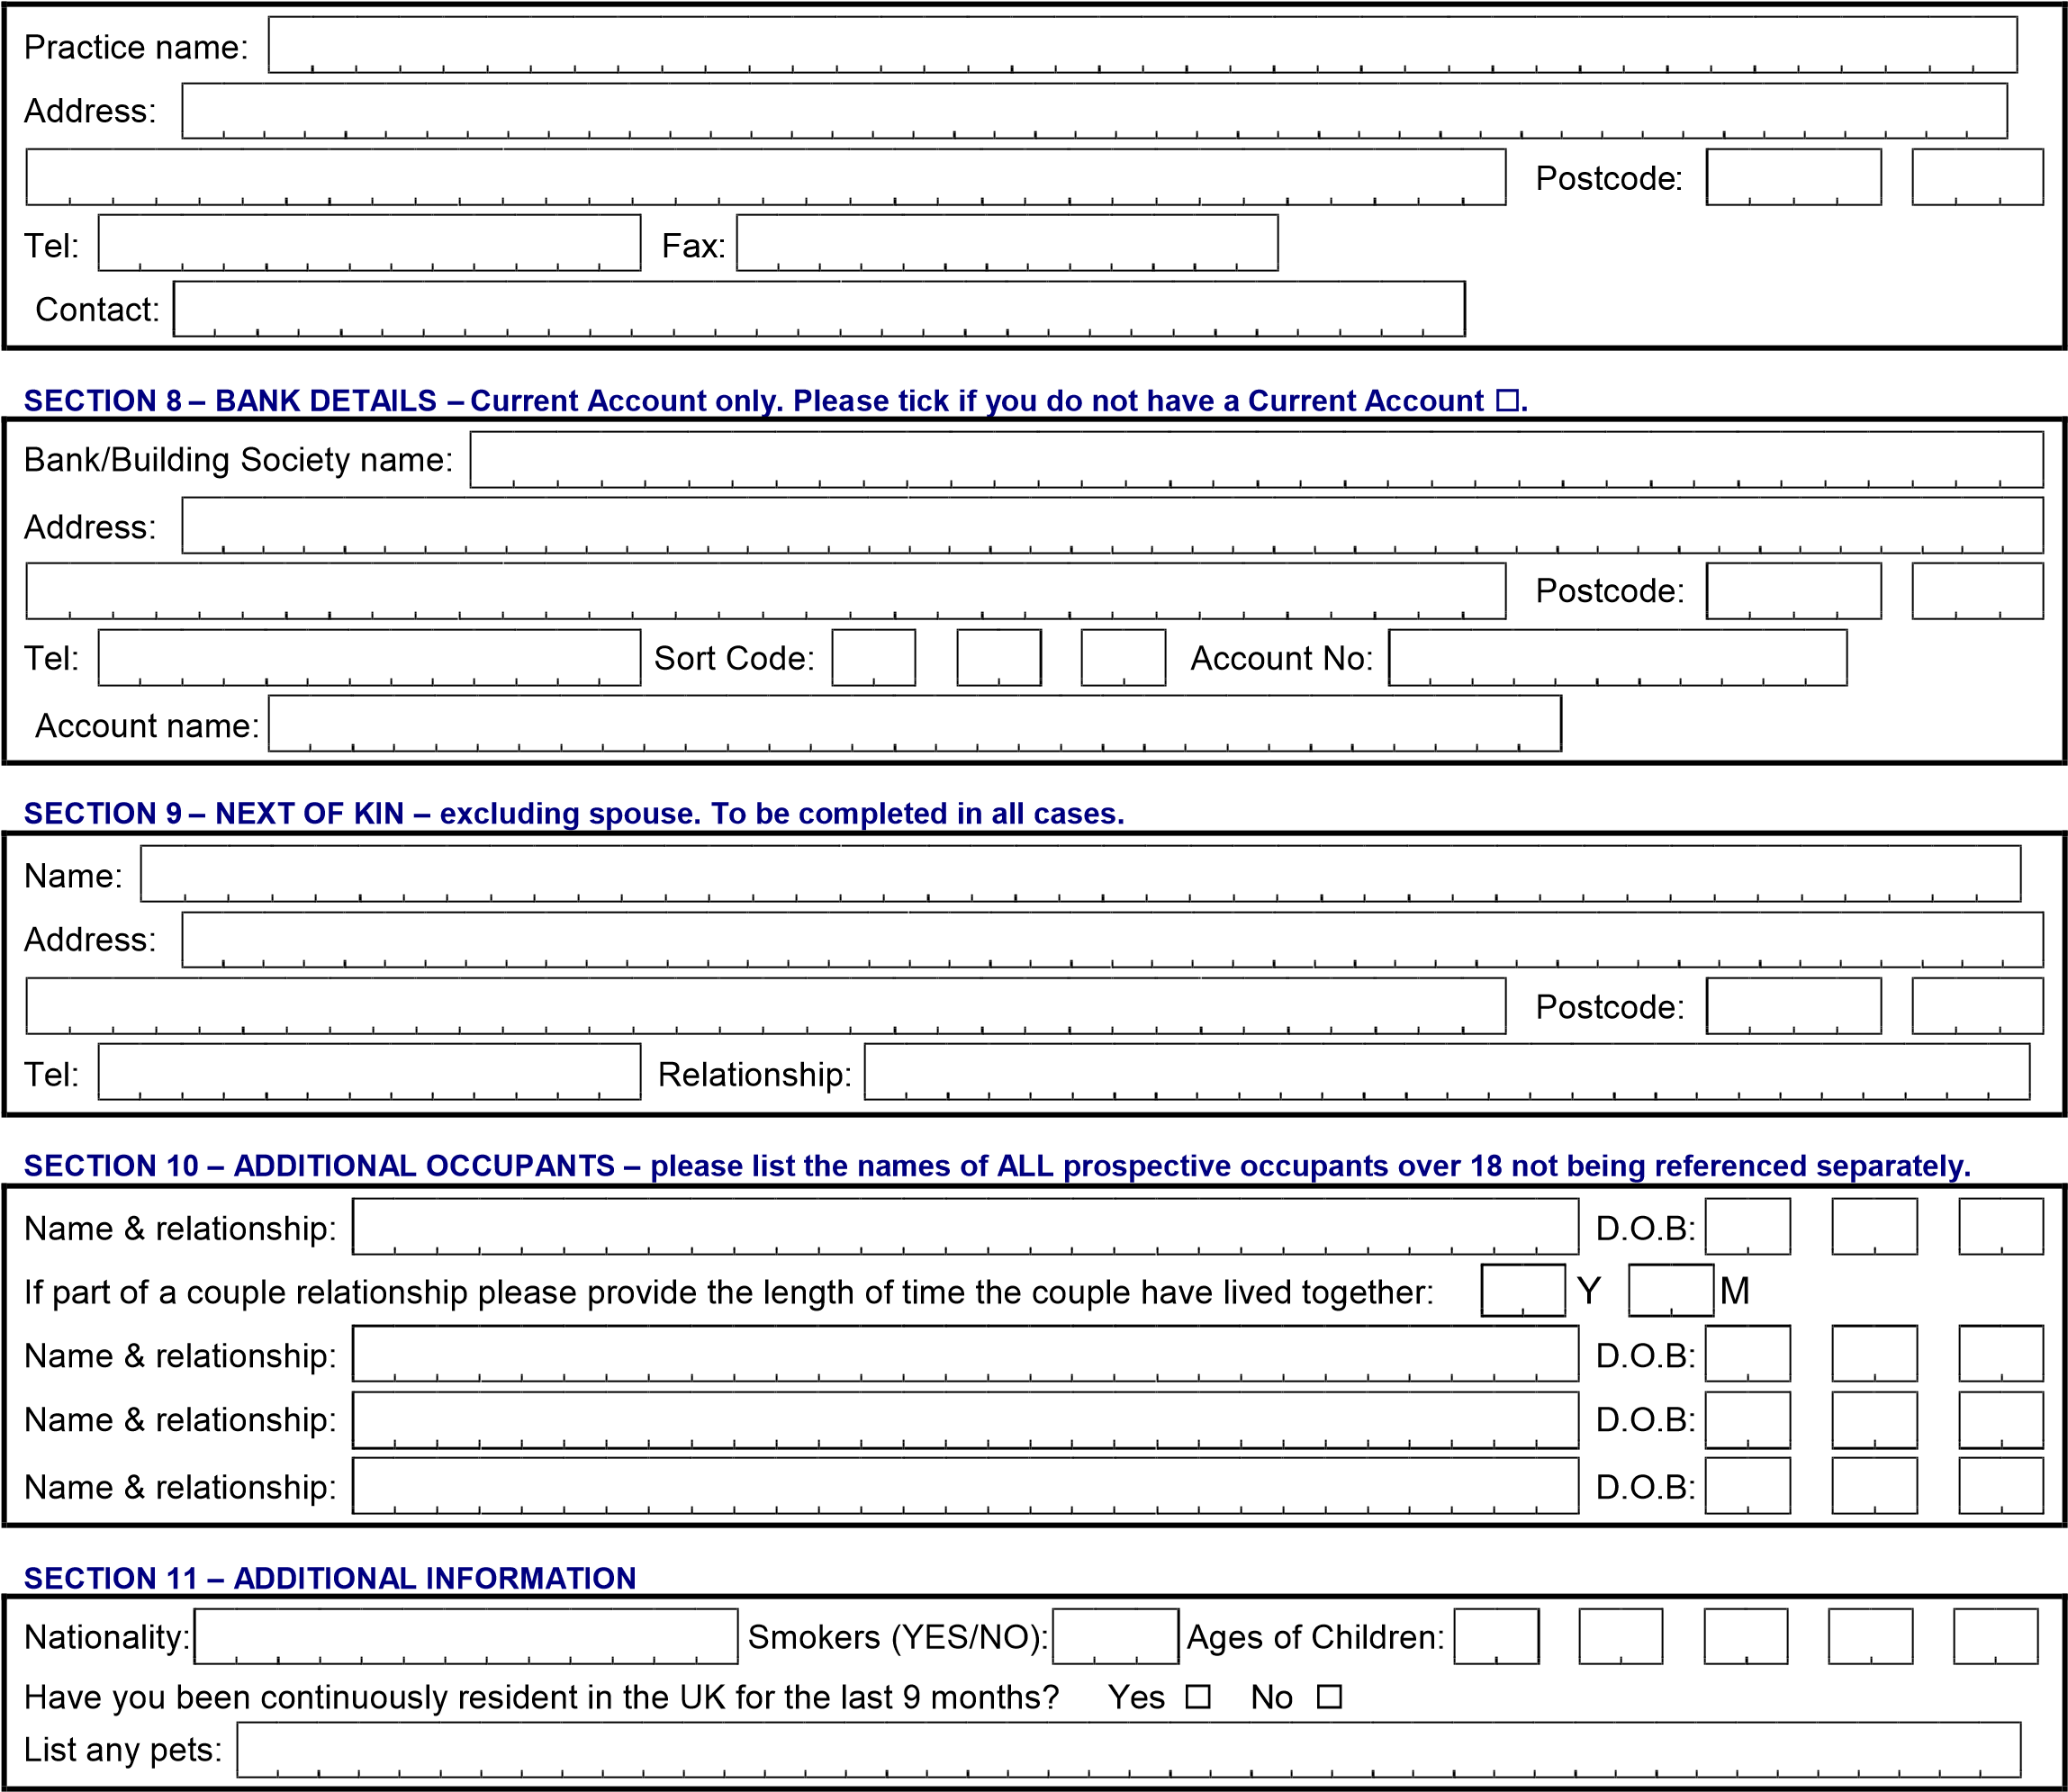
SECTION 12 – DECLARATION
I/We hereby confirm that the information provided by me/us is, to the best of my/our knowledge, true and that the results of the findings will be forwarded to the appointed letting agent and/or the landlord and may be accessed again should I/we apply for a tenancy agreement in the future. I/we agree that LetsXL Limited (the Data Controller) may search the files of a credit reference agency which will keep a record of that search. I/We also agree that any search will be made on an ‘opt in’ basis. I/We also understand that no details of the search will be given to me/us by the letting agent and/or the landlord but I/we may request the name and address of the credit reference agency to whom I/we may apply for a copy of any information provided. I/We also confirm that, in the event of my/our defaulting on the rental agreement, any such default may be recorded with the credit reference agency and may affect any future application for credit I/we may make.
 Applicant’s Signature: Date:
It is common practice for employers, previous landlords and other referees to request written authorisation from you before they will release information to us. The following page is an authorisation letter which we ask you to complete by inserting your name, full address and signature. We will use this letter only when requested by your referees.

To: Whom it May Concern
Ref: Tenancy Agreement References Requested from Imperial Lettings
Dear Sir,
I of
Hereby authorise
you to release to Imperial Lettings
Lettings information relating to my employment, income or previous tenancies.
Please respond promptly to facilitate processing of my current application for rented accommodation.
Thank you.
Yours faithfully,
Signed:
Print Name:
Date:

